Guide to downloading and installing Oracle 11g on your own Windows Pc

**NOTE:**

**If you choose to do this you will not simply be connecting to the DIT Oracle installation.**

**You will be installing an Oracle database on your own machine and a client (SQL Developer) which will allow you to access it and execute commands.**

**You will therefore need to create an Oracle instance, set up a new user with a password, create a connection to YOUR database.**

**You can also use SQL Developer to connect to the DIT Oracle installation when using the DIT network.**

1. Download Oracle 11g Express Edition from Oracle Technical Network
2. Install– follow the default prompts
3. Once installed, from Start Menu -> All Programs -> Oracle 11g Express Edition
   1. Choose Run SQL Command

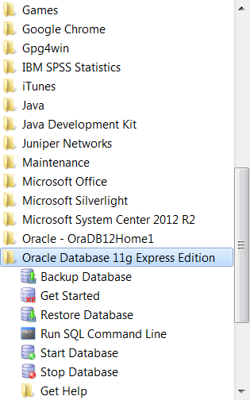

1. Connect as SYSDBA - the password is SYSDBA

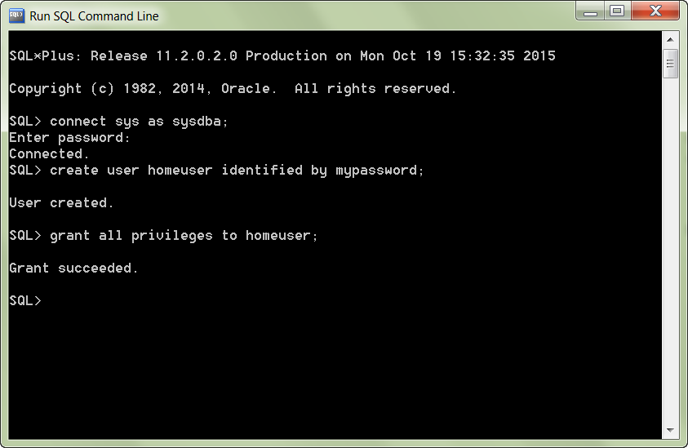

**Create a user with the username and password required**

Change this to the password you want

Change this to the username you want



**Grant the user privilege**



Change this to the username you created

1. Download and install SQL Developer from Oracle Technical network (if you need to)

**Create a Connection to your local Oracle instance using the username and password created**

**(NOTE These are NOT your DIT username and password)**

**You are also setting up a different type of connection**

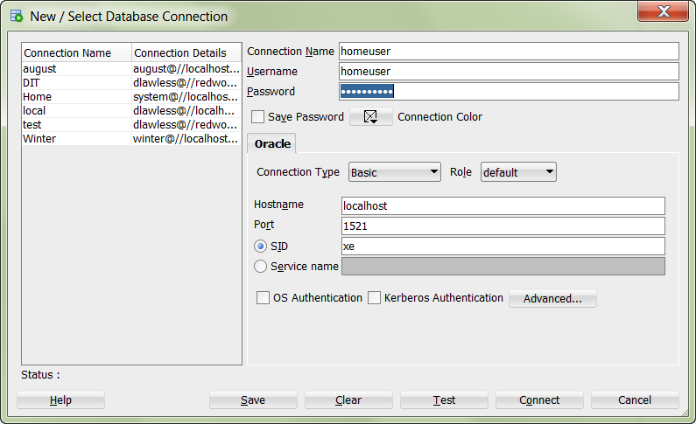

**Connecting to DIT’s Oracle database from your laptop.**

**Within SQL Developer, create a new connection as we discussed in class. You will need to be connected via the DIT Wifi for this to work.**